**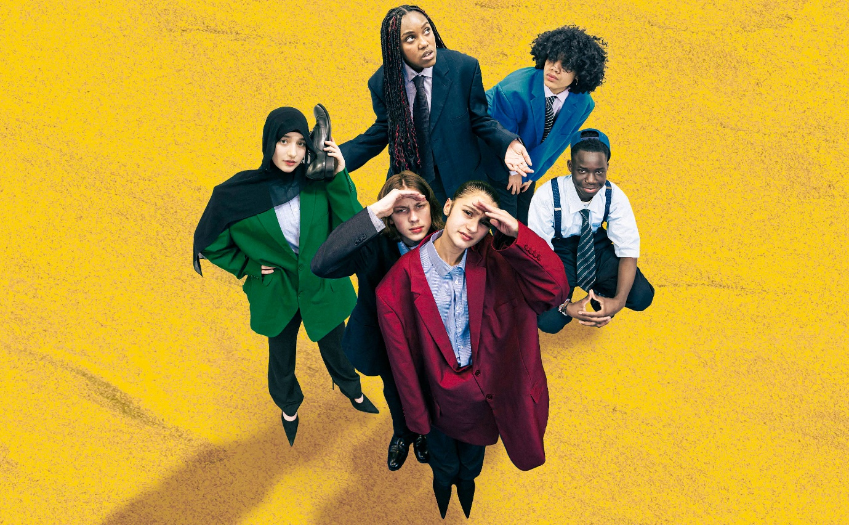Grow Up**

**Visual Story  
Show, venue and relaxed performance information**

**This visual story is designed for visitors to the performance of Grow Up.** This document contains **information about the venue, relaxed performances** and the **show** to help you prepare for your visit.

**Access information**

|  |  |
| --- | --- |
| We want to make sure **as many people as possible** get to experience this show. | People Icon Images – Browse 6,193,208 Stock Photos, Vectors ... |
| To help with this we are sharing information about the **venue,** the **show,** and **relaxed performances.** | What are accessible performances?10,595 Venue Icon Images, Stock Photos, 3D objects ... |

**Venue information**

|  |  |
| --- | --- |
| Grow Up is being shown at **Park Theatre**. | ParkTheatreOutside.png |
| Park Theatre is in **Finsbury Park**, near Finsbury Park **Station**. | Picture 2 |
| This is the **front entrance** of Park Theatre. | \\PTSRV01\Company\MARKETING DEPARTMENT\Visual Story\IMG_9831.JPG |
| There will be **ushers** who work at the theatre to **support** **you** if you would like them to. | Image preview |
| Grow Up will take place in the **Park 90 theatre**, which is on the **first floor** of the building.  You can use a lift or the stairs to get there. | Picture 3 |
| There is an **accessible, gender neutral toilet** and **baby changing** on the **lower ground floor** of the building. |  |
| **More** **access** **information** about Park Theatre is available here:  <https://parktheatre.co.uk/your-visit/accessibility/> |  |

**About the show**

|  |  |
| --- | --- |
| **Grow Up** is a new **theatre show** by **Company Three**. | Theatre Icon Vector Art, Icons, and Graphics for Free Download |
| **Company Three** make theatre with **young people from Islington**. |  |
| The show will be **60 minutes** long with no interval. | 60 minutes - Free time and date icons |
| There are **eight young people** in the show. They are:  Basiru, Hattie, Ilia, Isaiah, Mylo, Renata, Shayma and Shiloh.  They each play themselves at different points in their lives. | A person wearing a hat  Description automatically generatedA person with blonde hair  Description automatically generatedA person with long hair  Description automatically generatedA close-up of a young person  Description automatically generatedA person with curly hair  Description automatically generatedA person in a white shirt  Description automatically generatedA person wearing a black head scarf  Description automatically generatedA person with a necklace and a cross necklace  Description automatically generated with medium confidence |
| The next **2 pages** **say what happens** in the story and describes the **set** and **costume.**  If you do not want to **spoil the surprise**, **go to page 8.** | Book Reading Computer Icons PNG - black ...Stop sign - Free signs icons |

|  |  |
| --- | --- |
| **About the story** | |
| The characters receive **an invitation** to go on a **journey** to **different moments** in their **lives.** | Communication, government, letter ... |
| They **travel forwards and backwards in time.**  We see them in **the womb,** as **older people**, at a **school sport’s day**, as **middle-aged** adults at **work**, and **on the beach** as **young children**. | Time travel Basic Rounded Lineal icon |
| They talk about **love**, **growing up** and the **pressures put on young people.** | Growing up - Free people icons |
| The play finishes with the group **looking at the stars** and thinking about **infinity** and the **universe**. | Astronomy, galaxy, nature, night, sky ... |
| There are **joyful** moments, **humour** and **some serious moments.** | Happiness - Free people iconsSerious Face Icons - Free SVG & PNG Serious Face Images - Noun Project |
| They talk about **moving country,** **family, climate change** and **neurodivergence.** | Climate Change Icon Images – Browse 73,838 Stock Photos ...Family silhouette - Free people iconsBrain Icon Images – Browse 543,331 ...  Vector Design Migration Icon Style 22271125 Vector Art at ... |
| **What the play looks like** | |
| There will be **curtains behind the stage** and **rectangular blocks** on the stage that the cast will sit and climb on.  There will be lots of **ball-pit balls** that spill across the stage. |  |
| The cast will wear **colourful clothing.** | Fashion - Free fashion icons |

**Relaxed performance**

|  |  |
| --- | --- |
| **Every performance** of Grow Up is **relaxed.** | Chill-Out Icons - Free SVG & PNG Chill-Out Images - Noun ProjectWhat are accessible performances? |
| You can **make noises**, **move** around or **respond naturally** and we know that attention looks different for different people. | Lying man posture silhouette - Free ...Hand-Drawing Icons - Free SVG & PNG Hand-Drawing Images - Noun Project  Talking Person Icons - Free SVG & PNG Talking Person Images - Noun Project  Fingers, gesture, hand, move, right ... |
| You can **leave** and **come back** in at any time. |  |
| There will be a **chill-out zone** outside the main performance space.  The space is designed to give you **space** and **comfort** if you want to take time out from watching Grow Up.  There will be **fidget toys** available in the chill-out zone. | A room with tables and chairs  Description automatically generatedHappy face - Free smileys iconsChill-Out Icons - Free SVG & PNG Chill-Out Images - Noun Project |
| The **sound** levels of the performance will be **low** and there will be **no loud** or **sudden music** or **sound effects**.  The **lighting** will **not flicker or strobe** and there will be **low lights in the space throughout** the performance.  There will be a **static Mirrorball** which may cast a **small amount of moving light.**  There will be **low level haze** throughout the performance. | Disco ball - Free entertainment iconsLight icons for free download | FreepikLow, sound, speaker, voice, volume icon - Free download |
| If you have any **questions** about the show or to discuss your access requirements, please:  Email: **gabi@companythree.co.uk**  Phone: **07547390364** | email" Icon - Download for free – Iconduckcall" Icon - Download for free – Iconduck |